Transport inefficiencies in the cocoa value chain
in Côte d’Ivoire: Is sustainability possible?
Simeon Human¹, Dr. Ingrid Fromm²
1Master’s Graduate of the HAFL and PhD candidate at the Royal Agricultural University, Cirencester, United Kingdom, 10418130@rau.ac.uk
2Bern University of Applied Sciences, School of Agricultural, Forest and Food Sciences (HAFL), Zollikofen, Switzerland, ingrid.fromm@bfh.ch
ABSTRACT
We examine transport inefficiencies and the sustainability of the cocoa value chain (CVC) in Côte d’Ivoire. Based on the findings, actionable recommendations are made to improve the sustainability of cocoa transport from farm gate to export harbour. In terms of method, we begin with a literature review of transport inefficiencies in the Ivorian CVC from farm gate to export harbour. This is followed by primary research conducted on-site in Côte d’Ivoire. Qualitative and quantitative data were gathered, based on a 57-question questionnaire, and in-depth interviews with key stakeholders. Respondents include two main cooperatives - Société Coopérative des Planteurs d’Iratéké (SOCOOPI) and Société Coopérative Agricole Badéya Soubré (SOCOOABAS) – and three different villages - Djihimbo, Iratéké and Konédougou. Special function actors from the Soubré, San-Pédro and Grand-Béréby corridors also participated. The CVC functions within a combined micro, meso and macro business enabling environment. The micro environment holds the CVC that is the focus of this study. The steps of the CVC flow horizontally and sequentially. Farmers, cooperative management, exporters, ports, chocolatiers, and supermarkets are the major actors in the different steps of the CVC with each actor also having its own value chain. The lines that these actors engage in, flow vertically and are called primary and support activities. These lines serve the purpose of achieving competitive advantage. The micro environment is surrounded by the meso environment including medium-sized actors and the macro environment, in turn, surrounds the meso environment including larger entities. Trucks and motorcycles are the dominant forms of transport from farm gate to export harbour. Significantly, there is no railway system that could efficiently be used in the CVC. Transport inefficiencies include insufficient village collection points, blocked roads during rain due to lack of profiling and tar, excessive reparations costs due to potholes and low-quality roads, excessive pollution caused by trucks, “pisteurs” lowering the value chains’ credibility, and a lack of bank branches at junctions where trading takes place. Sustainable transport is measured using the United Nation’s criteria of which the results show that transport is mostly unsafe, unaffordable, inaccessible, inefficient, not resilient and that the emission of carbon and other gases are not sufficiently minimised. In conclusion, cocoa transport in Côte d’Ivoire is unsustainable in its current form. However, with the correct implementation of policy measures, financing and technological innovation, there is significant potential to improve the status quo.
Keywords: Transport; Sustainability; Cocoa; Value Chain; Côte d’Ivoire.

1. Introduction

In December 2017, global leadership renewed a call to carbon neutrality (One Planet Summit, 2017). In this paper, we identify strategies that improve the efficiency and sustainability of cocoa bean transport, thereby contributing to the goal of carbon neutrality. According to the International Trade Centre and the Mediterranean Shipping Company (2015; 2016), Côte d’Ivoire is the world’s top exporter of cocoa beans by volume and sales. However, a living income remains out of reach for its cocoa farmers (International Cocoa Organization, 2022). Furthermore, current transport solutions (Figure 1) are incompatible with the future architecture of global value chains (Figure 2).

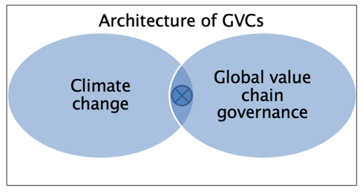
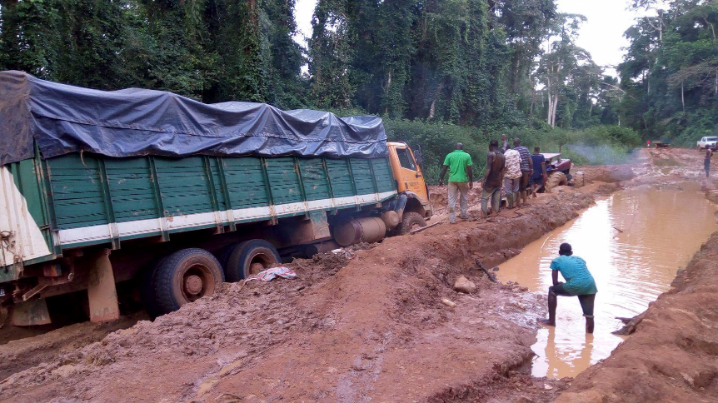
Figure 1 Current challenges
Figure 2 Research context
The future of sustainable cocoa is under threat. One possible solution is to invest in improved transport of cocoa beans from farm gate to export harbour. We argue that reduced transport inefficiencies in the cocoa sector increases farmers’ income. Furthermore, improved transport along the cocoa value chain contributes to logistics worldwide, and subsequently to better governance of global value chains. As Shepherd (2013) asserts, the discipline of logistics unites developed and developing countries, makes use of technology and promotes best practice.

2. Objectives
To address the conference theme of improving farmer income, we answer five research questions:
- How satisfied are cocoa farmers with their wages (i.e., their income)?
- What transport methods are used to take cocoa from farm gate to export harbour?
- Which transport inefficiencies currently inhibit sustainability along the Ivorian cocoa value chain?
- How do farmers and special function actors rate modern methods of cocoa transportation?
- What is the potential for improving efficiency in transport with respect to society, costs, and greenhouse gas emissions?

3. Methodology
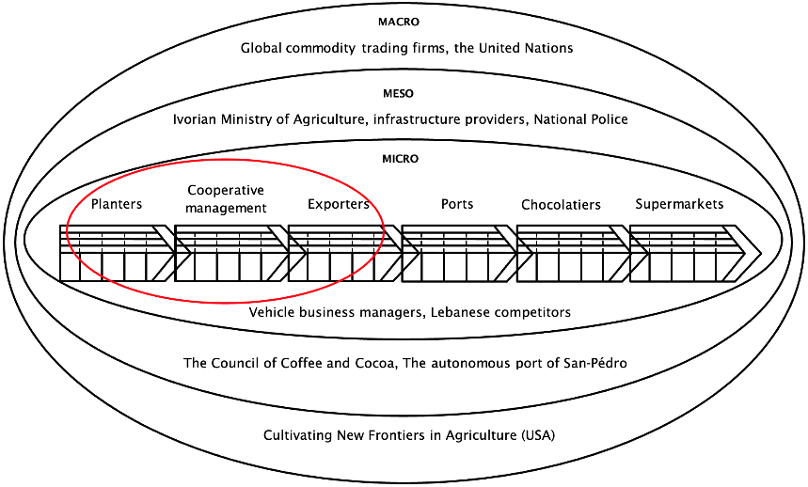
From the perspective of this research, the major actors that form the backbone of the global cocoa value chain are farmers (also known as planters), cooperative management, exporters, ports, chocolatiers, and supermarkets. Data pertaining to these actors are analyzed using Michael Porter’s concept of a “value chain” as a point of reference (Porter ME, 2008). Figure 3 shows an idealized depiction of the complexity of cocoa value chain in Côte d’Ivoire and globally. We focus our research questions on the first three actors, as indicated by the red oval.
Figure 3 Depiction of the Ivorian cocoa value chain. The red oval indicates the study’s area of focus (illustration: author’s work adapted from (Porter ME, 2008)).
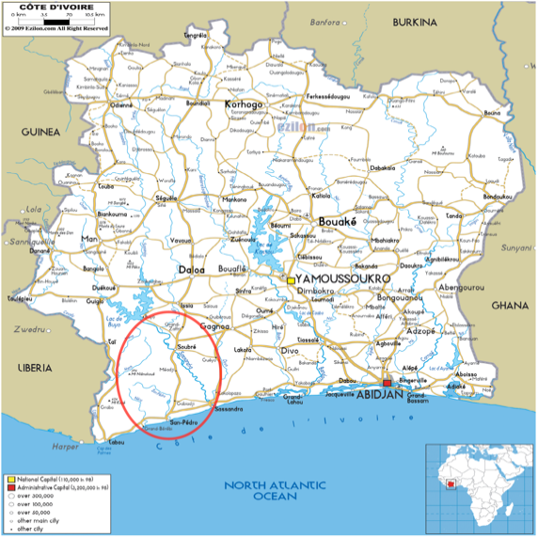
In our study, the primary and support activities in the cocoa value chain take place at the following locations: on the farms in Konédougou, Djihimbo or Iratéké, at the collection centres in Konédougou, Soubré or Iratéké, at the factory of the exporter in San-Pédro, at the autonomous port of San-Pédro, and on the roads and in the transport modes in between these steps. Three major factors that are needed to make transport sustainable were focused on. According to the Mobilizing Sustainable Transport document by the United Nations, these factors are policy development and implementation, financing, and technological innovation. The questionnaire was built with reference to these three factors as main starting point, as well as a study on improving cocoa quality in the Soubré region by Silvano Allenbach (Allenbach S, 2014; United Nations, 2016).
Figure 4 Road map of Côte d’Ivoire. The red oval indicates the region where primary data was collected (Map source: (Ezilon, 2009)).
Data collection was completed using two methods: a six-question in-depth interview and a 57-question questionnaire. Nine sites were studied using the in-depth interview method and ten sites were examined using the 57-question questionnaire method. The six-question in-depth interview was completed by 15 respondents. The 57 question-questionnaire was completed by 138 respondents. Where appropriate, and where opportunity presented itself, both methods, in full and in part, were used for the same actor type. A total of 16 actor types responded. These include Cooperative: Director, Trainer, Operations (collection centre manager), Administrative Council President, Vice-President; State: Cocoa Coffee Council agent (quality price controller), Phytosanitary: agent; Ministry of Agriculture: Director General; Vehicle commerce: Store owner & manager; National Police: mid-management (Lieutenant), senior management (Prefect); Exporter: Export director, Director of Administration and Finance, local trade, transport president; Transportation by truck: 40-tonne truck driver.
The 57-question questionnaire was completed by respondents from three farm gates. The project leaders of “Maximizing Opportunities in Cocoa Activity” of the investment group “Cultivating New Frontiers in Agricultural” recommended that farm gates be studied close to and further away from the export harbour. Two farm gates operated by one cooperative are close to the export harbour and are neighbours. The third farm gate is operated by another cooperative and is located further away from the export harbour. Support in the field allowed contact with these three farm gates.

4. Results
This section is structured to answer the paper’s five research questions. Firstly, cocoa farmers’ wage satisfaction. Secondly, transport methods. Thirdly, transport inefficiencies. Fourthly, transport sustainability scores. Finally, the potential benefits of improving transport.
4.1 Cocoa farmers’ satisfaction with regards to their wages (i.e., income)
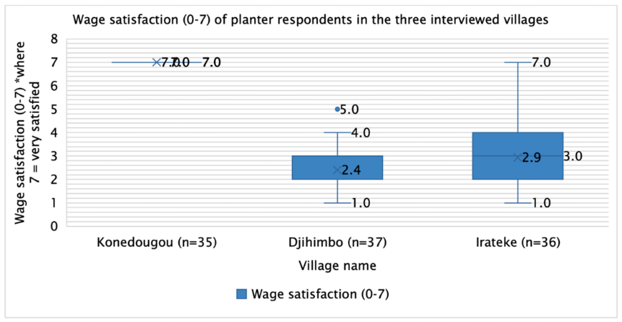
Out of a total of 108 cocoa farmers, more than two thirds indicate a mean average wage satisfaction below 3.1 out of 7, where 0 means very unsatisfied and 7 means very satisfied. This reveals an opportunity to improve wage satisfaction among cocoa farmers. In figure 5, the median replaces empty cells and quartile calculations are made inclusive of the median.
Figure 5 Cocoa farmers’ wage satisfaction (0-7, where 0 means not satisfied at all and 7 means very satisfied) in the three villages of Konédougou, Djihimbo and Iratéké.
The smaller interquartile range for the village of Konédougou may be explained by the fact that the farmers’ employers were present when the questionnaire was being conducted. However, it is possible that all farmers in that questionnaire are truly satisfied with their pay. Group mentality may also be a factor since the questionnaire was conducted with all farmers of the village together under a tent. The employers in the villages of Djihimbo and Iratéké were also present and yet the interquartile ranges were higher for these questionnaires than for Konédougou. Perhaps this difference is because the employers for Djihimbo and Iratéké are different to those of Konédougou. Regardless, it is worth noting that most of the farmers cannot read or write, but that each of them has a voice and is able to answer and ask questions as well as tell stories.
4.2 Transport methods from farm gate to export harbour
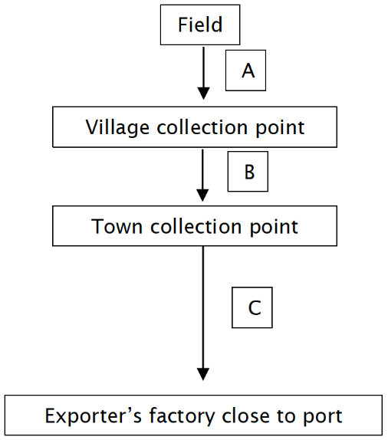
The transport method depends on the segment of the cocoa bean bag’s journey. Figure 6 shows how segment A is from field to village collection centre (0-12km), segment B is from village collection centre to town collection centre (5-40km), and segment C is from town collection centre to exporter’s factory close to port (30-300km).
Figure 6 Depiction of transport segments “A”, “B” and “C”.
Each segment has its own list of typical transport methods, as outlined below.
Segment A - from field to village collection centre (0-12km):
- On foot
- By bicycle (60-120kg carrying capacity)
- Un-motorized tricycle
- Motorized tricycle
- Pickup truck
- Tractor (3-8 tonne carrying capacity)

Segment B – from village collection centre to town collection centre (5-40km):
- Trucks (3-5 tonnes carrying capacity)
- Boats
  - “Pirogue” boat (100-500kg carrying capacity)
  - “Bacs”
  - “Pyro pinasses” to transport across rivers e.g., Sassandro and Lobo
  - River boat

Segment C – from town collection centre to exporter’s factory close to port (30-300km):
- Trucks (with carrying capacities of 10, 15, 20, 25, 30, and 40 tonnes)
Further information applying to Côte d’Ivoire territory generally are as follows. No trains, helicopters or planes are used for the transport of cocoa bean bags. Certain villages do not have the privilege of working with many vehicles because they simply cannot afford them. Consequently, transport methods used for cocoa are also used for the benefit of sister value chains, such as coffee, rubber, palm oil, cajou nuts, manoc and mango. Incidentally, Côte d’Ivoire is the world’s top exporter of cajous, ahead of India, and is the world’s third most important exporter of palm oil. Finally, horses and donkeys are sometimes used to transport produce in Northern Côte d’Ivoire.
4.3 Transport inefficiencies currently inhibiting the sustainability of the Ivorian cocoa value chain

4.3.1 Doubling up on distances due to insufficient village collection points
In segment A, farmers working fields numbered “10-18” are obliged to transport their beans away from rather than to the export harbour due to a lack of village collection points en route to the next destination. This inefficiency, where beans make a part of the journey twice, is illustrated in figure 7.
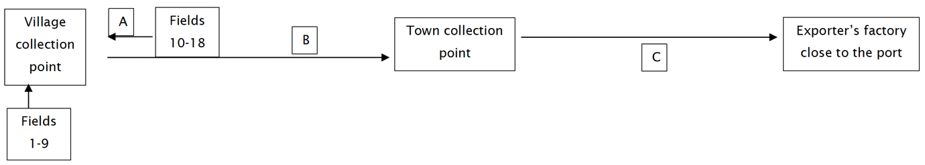
Figure 7 Schematic showing the lack of village collection points in segment A, causing inefficient doubling up of distances.
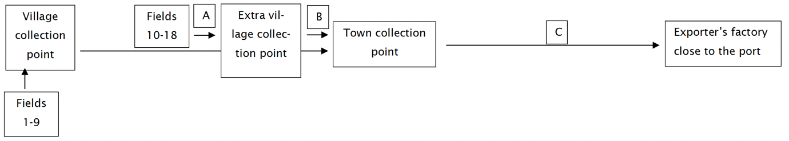
The inefficiency shown in figure 7 could be reduced with the strategic placement of new village collection points, as illustrated in figure 8.
Figure 8 Carefully planned installation of extra village collection points between segments A and B eliminates inefficient re-routing.
In deciding when, where and how the new collection points are built, business plans and feasibility studies will provide the necessary background information.

4.3.2 Blocked roads during rain due to lack of profiling and tar
In segment B (see figure 6), dirt roads connecting the village and town collection centres are unprofiled. On rainy days, which occur frequently and heavily, the road network becomes impassable. Despite best efforts, all vehicles become stuck, and goods are normally lost. This provokes unnecessary delays when vehicles break down (see figure 1) along with the subsequent repair costs. On many of these roads, trucks are rendered out of service. Furthermore, some zones become completely inaccessible, which is a significant waste because there is cocoa and rubber available. The roads are such that operators must change vehicles every two years.
The data does not clearly indicate which roads on segment B are worst affected by rain. A first suggestion to assuage the problem is the periodic re-profiling of dirt roads in segment B. Some companies already implement this strategy and charge cooperative drivers a fee to pass on their roads, generating a new income stream. Secondly, the installation of basic drainage systems is advised, especially at known high flood risk areas. These changes need to be directed by experienced firms and personnel.

4.3.3 Excessive repair costs due to potholes and low-quality roads
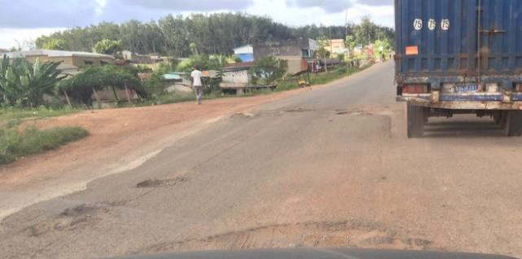
In segment C (see figure 6), tarred roads from the town collection centres to port-side exporter factories are riddled with potholes and in a very poor overall condition. This causes increased wear and tear of vehicles as well as higher quantities and intensities of road accidents. These consequences increase repair costs of vehicles and slow the operational flow of products.
Figure 9 Potholes in segment C, causing excessive reparations costs and slowing operational flow.
Some actors claim that road networks in segment C are the most pressing problem to resolve. Apparently, San Pedro is a particularly difficult section because of the rain. The photo above does not reveal the true extent of the problem. On the international road between Abidjan and San Pedro, for example, the road is not operable, to the point that it would be inaccessible for non-four-wheel drive vehicles. A comment made by an exporter is that “sustainability is an ideal to strive for, but that reality needs to be dealt with first”.

4.3.4 Excessive pollution caused by trucks
A large majority of the 40-tonne trucks are imported from abroad having already completed more than 10 years of service. While in operation in Côte d’Ivoire, few to no periodic controls are performed to optimize their performance and climate efficiency. Consequently, their carbon footprint starts high and continues to increase throughout their service.

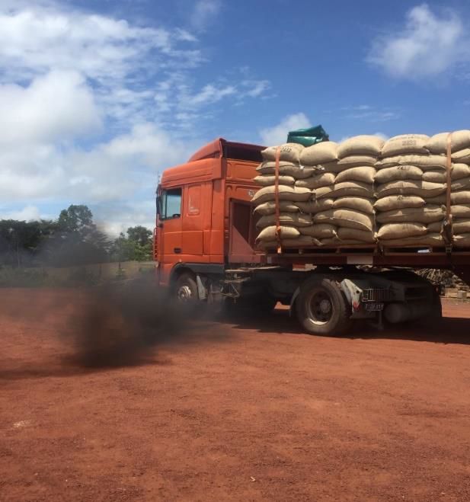
Figure 10 Excessive pollution caused by trucks.
Data collected from more than 100 indirectly related actors supports the over-arching message that current technologies pollute too much and need to be adapted. As the San Pedro Police Prefect claims, the farmer’s successful work is not complemented by the vehicles and roads that are in disrepair.

4.3.5 “Pisteurs” lower the value chain’s credibility
“Pisteur” is the title given to someone who informally and independently exchanges cash for cocoa and transports the product. These actors may appear to be the “quick fix”, especially to farmers short on income. However, their effect on the value chain is a degradation of the credibility of all actors, especially that of cooperatives. It is underlined by cooperative management that in future, the function formerly performed by “pisteurs” should be exclusively undertaken by formally appointed, ethically concerned actors.
Criminalizing “pisteur” work may create unwanted side-effects. The alternative is to professionalize the transport phase from village to town collection centre. This is a difficult task due to low literacy rates in rural areas. However, improved roads would lead to improved access to schooling which would, in the longer-term, yield higher rural literacy rates. Thus, a virtuous cycle of better education and professional transport would begin.

4.3.6 Lack of bank branches at junctions between segment B and C roads
There is a shortage of bank branches at the junction between dirt roads and tarred roads, which is to say between segments B and C (see figure 6). This is the point where 3 to 5-tonne trucks transfer their products to the 30 to 40-tonne trucks. Because of the bank branch deficiency, transaction security is not optimized. Actors are forced to work with larger than necessary amounts of cash.
If more branches were opened close to the junctions of segment B and C roads, there would be increased chances of securing the transactions between farmers, cooperatives, and exporters. The issue of carrying bundles of cash would be resolved once farmers’ bank accounts could be credited by wire. Furthermore, the improvement of the business enabling environment would likely spur long term local economic growth across multiple value chains. However, this objective would need to be supported by local political authorities as well as the local population. Suggested banks to work with are BCIC and Eco Bank. One branch in Grand-Béréby and one in Grabo would be ideal. The CCC can also provide more informed suggestions as to regions where new bank branches should be established.
4.4 The quality of modern cocoa transport according to farmers and special function actors
Sustainable transport is measured in terms of the UN’s criteria of safety, affordability, accessibility, efficiency, resilience and minimization of carbon and other emissions (United Nations, 2016). These criteria correspond with specific SDGs (see section 4.5).
According to the data, modern cocoa transport is:
- Unsafe
- Unaffordable
- Inaccessible
- Inefficient
- Not resilient
- Not minimizing carbon and other emissions
There is consensus among respondents, both cocoa farmers and special function actors, that “nothing” is done to address the problem of sustainable transport presently. Some respondents point towards the state-run coffee and cocoa council to find a solution. Others suggest that it would be beneficial if entrepreneurs concerned themselves with sustainable transport in their own systems. Vehicle business managers assert that roads are the most important problem to resolve.
The state is encouraged to make every effort to improve the roads leading into the bush by collaborating with the mayors of those regions. It is proposed that next, sufficient trucks are sent to transport the mass of available Ivorian cocoa beans more effectively. A long-term proposition is the installation of a national railway system. However, for such a proposition to be implemented, efforts should be coordinated to secure good governance. This could be achieved if farmers and special function actors work closely with the local council and the state.
4.5 The potential impact of improving transport efficiency with respect to society, costs, and greenhouse gas emissions
The global indicator framework for the SDGs is used as secondary data (United Nations, 2018). In this framework, Sustainable Development Goals are presented with corresponding indicators. In table 1, responses from farmers and special function actors are linked with the corresponding SDG.

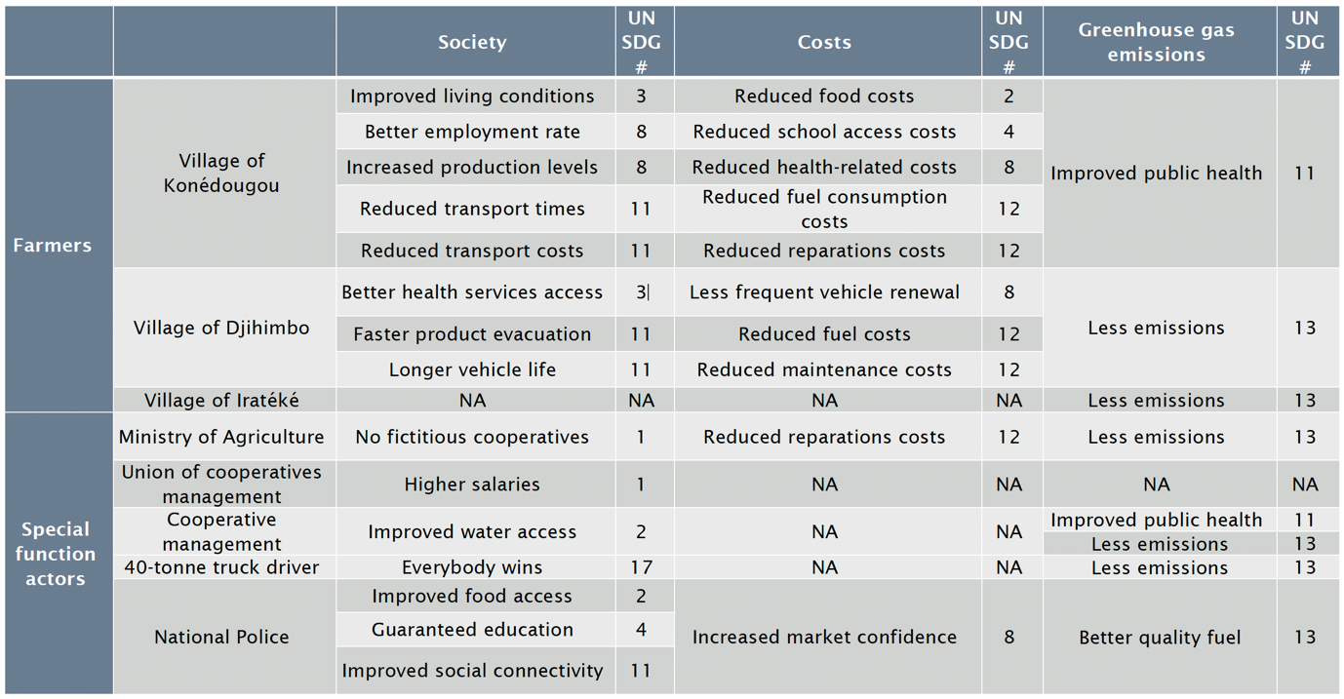
Table 1 The potential impact of improving transport efficiency with respect to society, costs, and greenhouse gas emissions
For society, Konédougou’s responses correspond to SDG numbers 3, 8 and 11. Djihimbo’s responses correspond to SDG numbers 3 and 11. Iratéké’s responses do not correspond with any of the SDGs. For costs, Konédougou’s responses correspond to SDG numbers 2, 4, 8 and 12. Djihimbo’s responses correspond to SDG numbers 8 and 12. Iratéké’s responses do not correspond with any of the SDGs. For greenhouse gas emissions, Konédougou’s responses correspond to SDG number 1. Djihimbo’s responses correspond to SDG number 13. Iratéké’s responses correspond to SDG number 13. It could therefore be inferred that Konédougou’s farmers have a more positive outlook on the potential. However, it can also be inferred that Iratéké’s farmers have a more realistic outlook.
As shown above, the inference can be made that the responses of the farmers and special function actors correspond to the indicators of the SDGs. This means that if the potential voiced by the respondents is reached, they would contribute to the achievement of the SDGs. In turn, this would lead to economic and social upgrading in global value chains since economic upgrading leads to social upgrading (Gereffi & Lee, 2016).

5. Limitations and future research
Two major limitations need to be addressed. Firstly, there was a loss of independence during data collection in that direct managers of farmers were present when sensitive questions were asked. Secondly, it is unlikely that an all-male sample of respondents (which was the case in this study) adequately represents the community’s gender and cultural identity.
Future research would contribute meaningful gains to knowledge if three study focus areas are considered. Firstly, semi-processed products. Secondly, the International Maritime Organization. Thirdly, the Conseil du Café Cacao and the Centre de Commandement des Opérations.

6. Recommendations
To contribute to the conference goal of improving cocoa farmer income, this paper makes the following recommendations:
- Build more village collection points at strategic locations.
- Invest in higher quality roads.
- Invest in improved vehicles.
- Professionalize the “pisteur” workforce.
- Open regional bank branches close to town collection points.
- Develop a cocoa-friendly, sustainable national railway system.

Acknowledgements
I would like to thank the organizing team of the ICCO for their efforts in running a successful conference in 2022.

References
Allenbach S. (2014). Improving Cocoa Quality: Effects of Centralized Fermentation on Physical Cocoa Quality Parameters and of Certification on Farmer Income in the Soubré Region, Côte d’Ivoire. Bern University of Applied Sciences School of Agricultural, Forest and Food Sciences.
Ezilon. (2009). Detailed Clear Large Road Map of Ivory Coast—Ezilon Maps. https://www.ezilon.com/maps/africa/ivory-coast-road-maps.html
Gereffi, G., & Lee, J. (2016). Economic and social upgrading in global value chains and industrial clusters: Why governance matters. Journal of Business Ethics, 133(1), 25–38. https://doi.org/10.1007/s10551-014-2373-7
International Cocoa Organization. (2022). Sustainable Cocoa Economy: A Comprehensive and Participative Approach. ICCO. https://www.icco.org/economy/
International Trade Centre. (2015). Chocothon Ghana—ToT Material—International Market Trends on Cocoa.pdf. https://www.sustainabilityxchange.info/filesagri/Chocothon%20Ghana%20-%20ToT%20Material%20-%20International%20Market%20Trends%20on%20Cocoa.pdf
Mediterranean Shipping Company. (2016). Your Expert in Cocoa Transportation. https://www.msc.com/getattachment/9069ea96-741c-4b7c-8773-cf1fc528de7b/636141332805547870
One Planet Summit. (2017, December 12). One planet summit—En. https://www.oneplanetsummit.fr/en/
Porter ME. (2008). Competitive Advantage: Creating and Sustaining Superior Performance (Kindle Edition 1). Free Press.
Shepherd, B. (2013). Aid for Trade and Value Chains in Transport and Logistics (p. 70). World Trade Organization. https://www.oecd.org/dac/aft/AidforTrade_SectorStudy_Transport.pdf
United Nations. (2016). 2375Mobilizing Sustainable Transport.pdf. https://sustainabledevelopment.un.org/content/documents/2375Mobilizing%20Sustainable%20Transport.pdf
United Nations. (2018). Global Indicator Framework for the Sustainable Development Goals and Targets of the 2030 Agenda for Sustainable Development. https://unstats.un.org/sdgs/indicators/Global%20Indicator%20Framework_A.RES.71.313%20Annex.pdf

